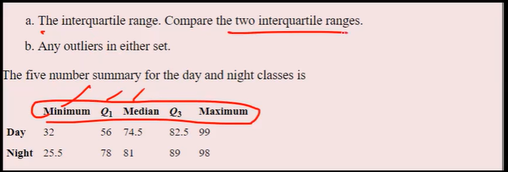

**Question 1: Compare the two interquartile ranges (IQRs).**

**Formula for Interquartile Range (IQR):**

IQR=Q3−Q1

**For the Day Class:**

* Q1 = 56
* Q3 = 82.5

IQRDay=82.5−56=26.5

**For the Night Class:**

* Q1 = 78
* Q3 = 89

IQRNight=89−78=11

**Comparison:**

* The interquartile range for the Day class is 26.5.
* The interquartile range for the Night class is 11.

**Conclusion:** The Day class has a larger interquartile range compared to the Night class, indicating greater variability in the middle 50% of the data.

**Question 2: Any outliers in either set.**

**Formula for Identifying Outliers:**

Outliers are values that fall below Q1−1.5xIQR or above Q3 + 1.5xIQR

**For the Day Class:**

* Lower bound = Q1−1.5×IQR = 56 - 39.75 = 16.25=56−39.75=16.25
* Upper bound = Q3+1.5×IQR = 122.25=82.5+39.75=122.25

Since the minimum value is 32 and the maximum value is 99, there are no outliers in the Day class.

**For the Night Class:**

* Lower bound = Q1−1.5×IQRQ=78−16.5=61.5
* Upper bound = Q3+1.5×IQRQ=89+16.5=105.5

Since the minimum value is 25.5, which is less than 61.5, **25.5 is an outlier** in the Night class. The maximum value of 98 is within the upper bound, so it is not an outlier.

**Conclusion:** There are no outliers in the Day class, but 25.5 is an outlier in the Night class.